Notes and updates:

Database created Tuesday by Evan

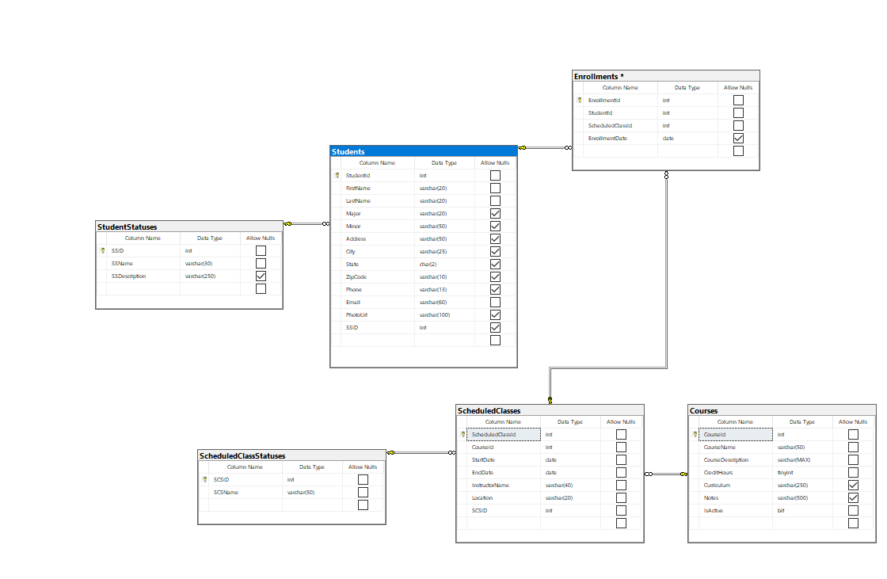

Created ASP.NET Web application Tuesday and connect to GitHub repository

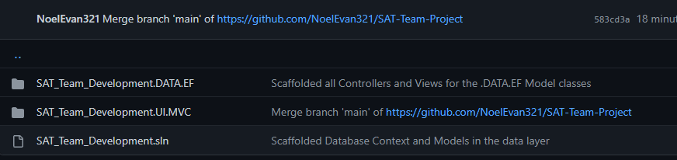

18Jan2023 Brice and Jeffrey Created _Archive folder in the UI layer, Data layer, mockup data, and all identity tables

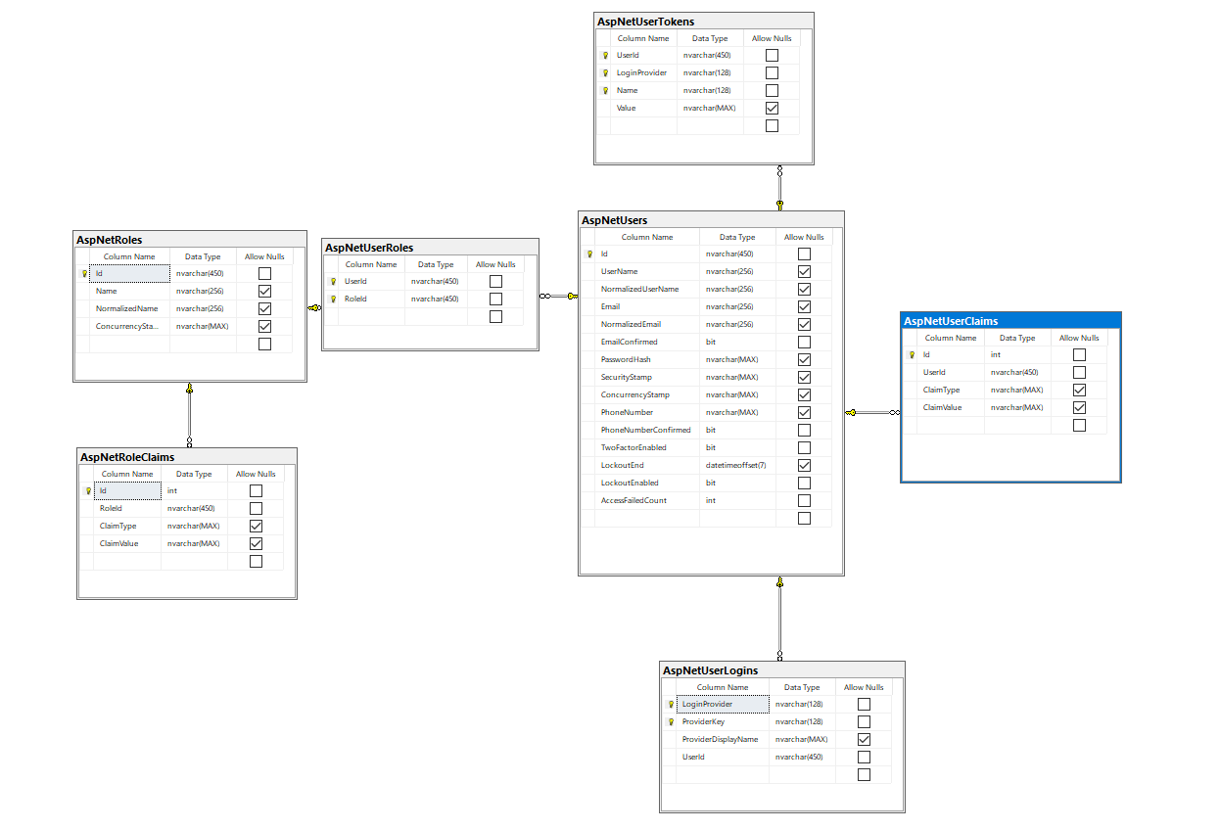

18Jan2023 Created all necessary metadata using data annotations and partial classes

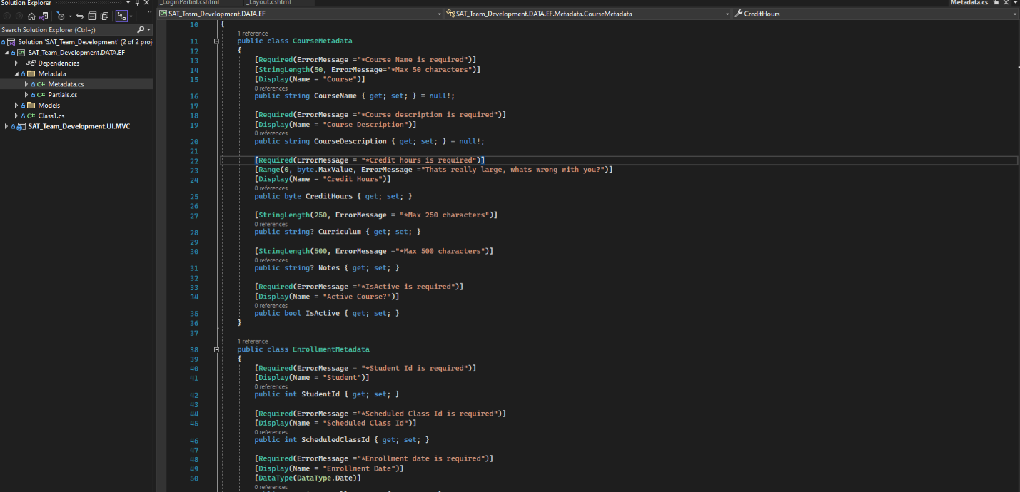

18Jan2023 we started converting the _Layout with our template code pulled in from the _Archive

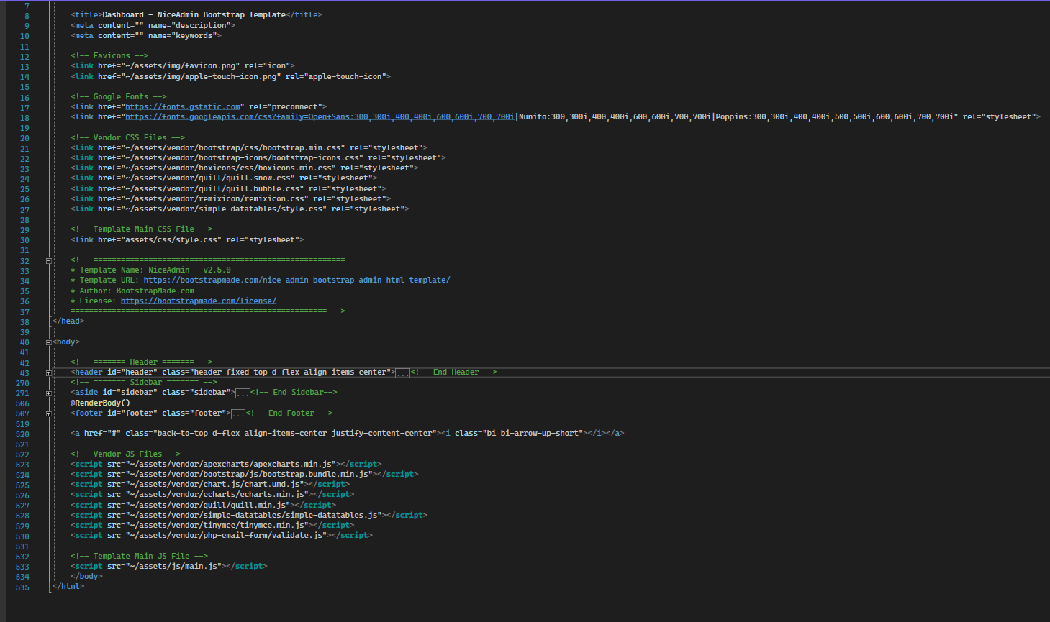

19Jan2023 we are continuing to work on converting the _Layout and overall template conversion

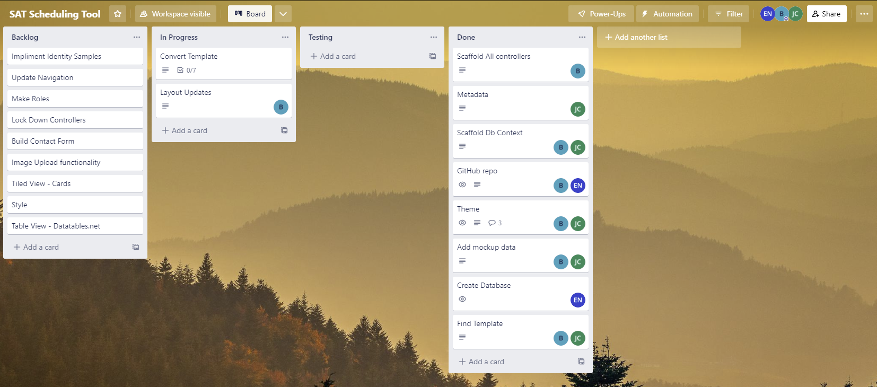

**Converting the tables to datatables:**

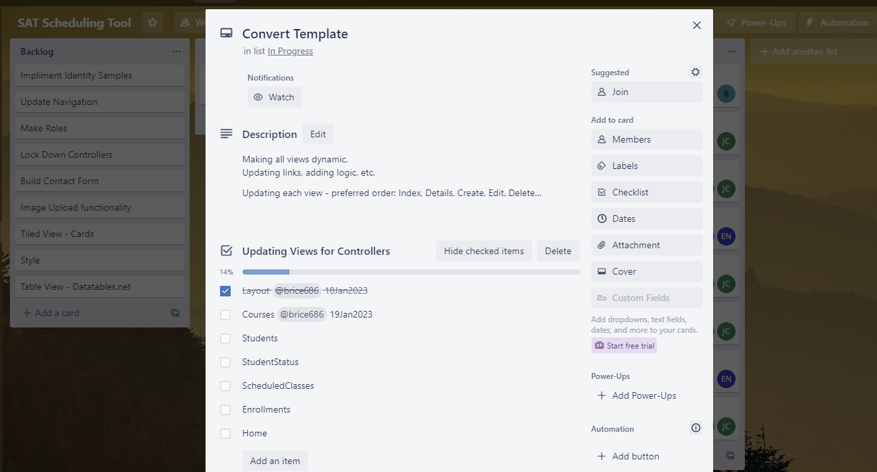

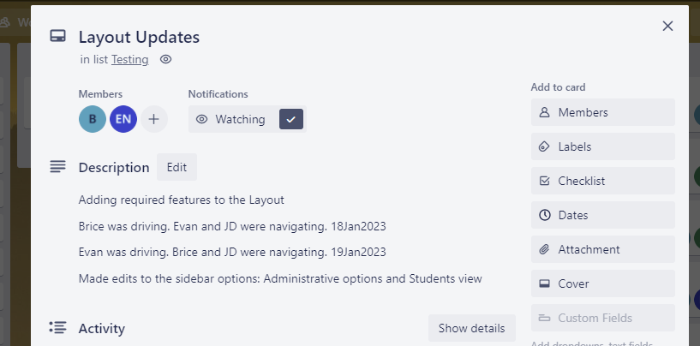

Sought to fix the cdn issues for data tables.

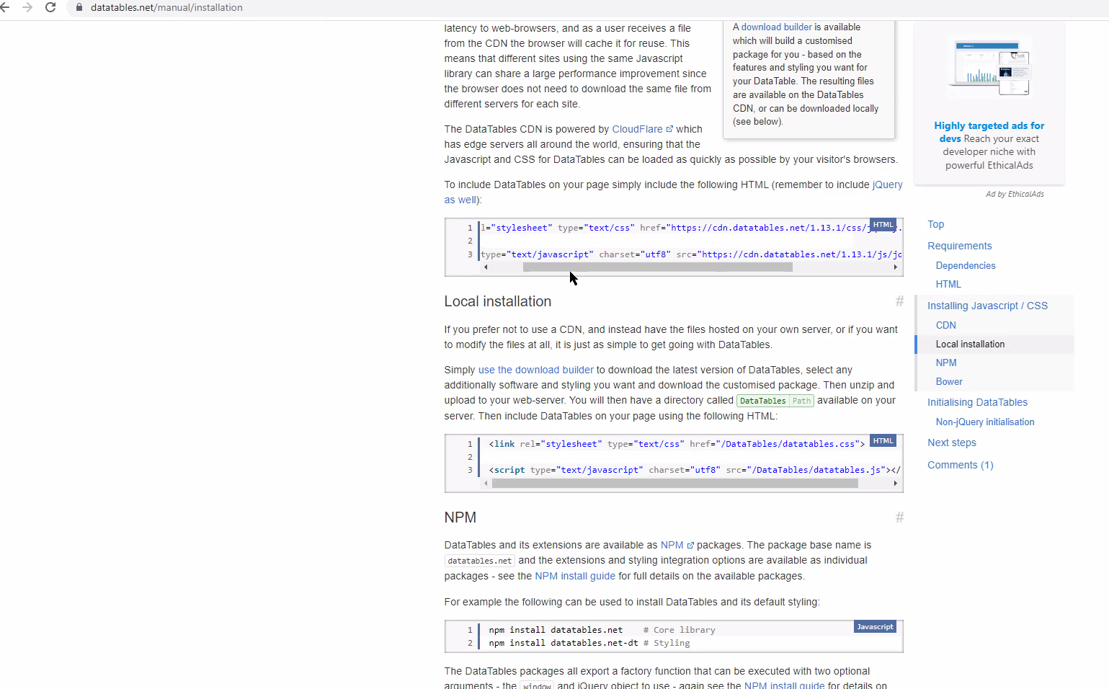

Layout was set to null.

Added a container to adjust for Header positioning.

Worked on centering Create, Edit, Details, and Delete views for Courses.

Added the ViewData[“Title”] and Model.CourseName for each.

Example of details view:

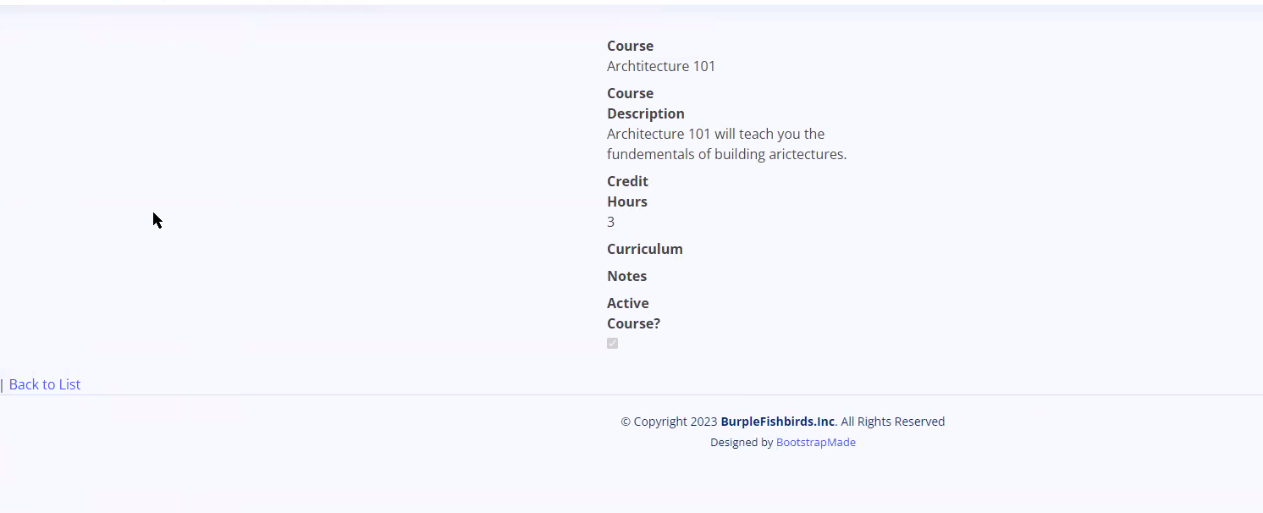

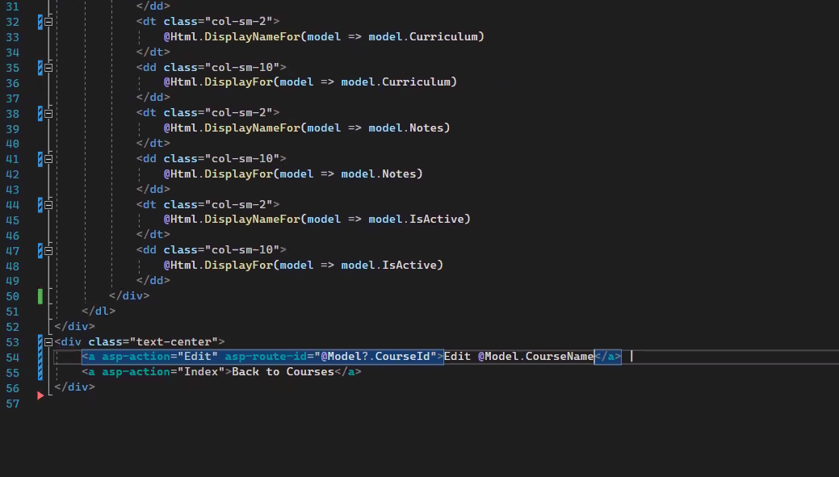

Added the create view for the courses action

Ran into an appsettings.json fix. Pushed to check. Continued with new branch for CRUD.

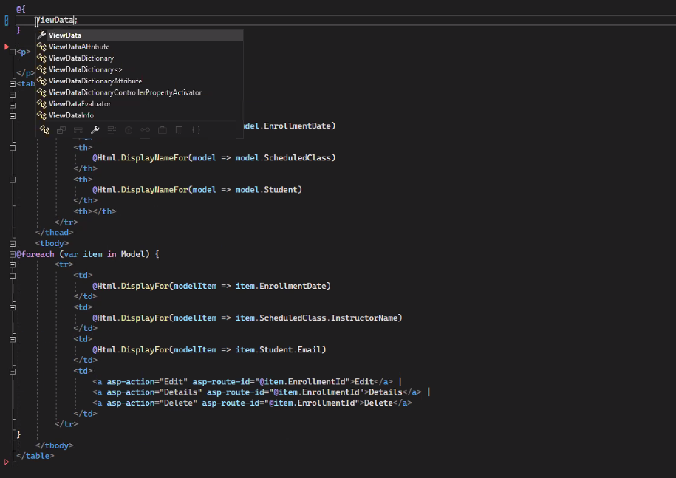

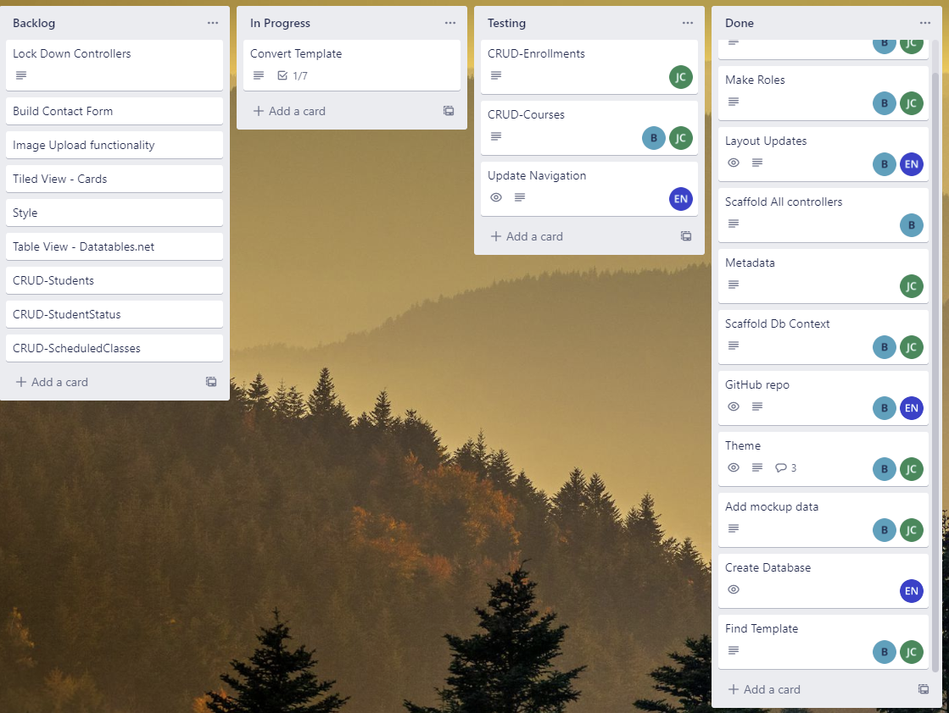

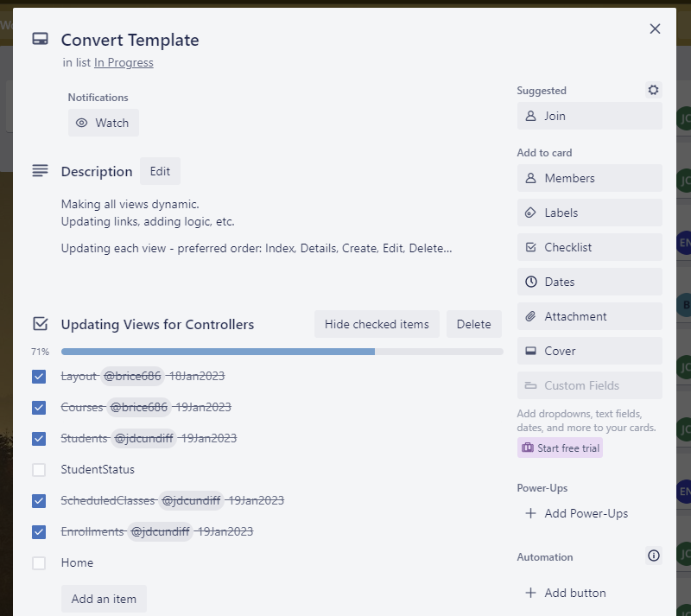

Tested links and checked that all data is being populated correctly.

#wish: For index in Enrollments if more time would add better identifiers for the classes themselves or we could just make the enrollment index easier to view.

#fix: edit for scheduledclasses was saving. Need to come back to that.

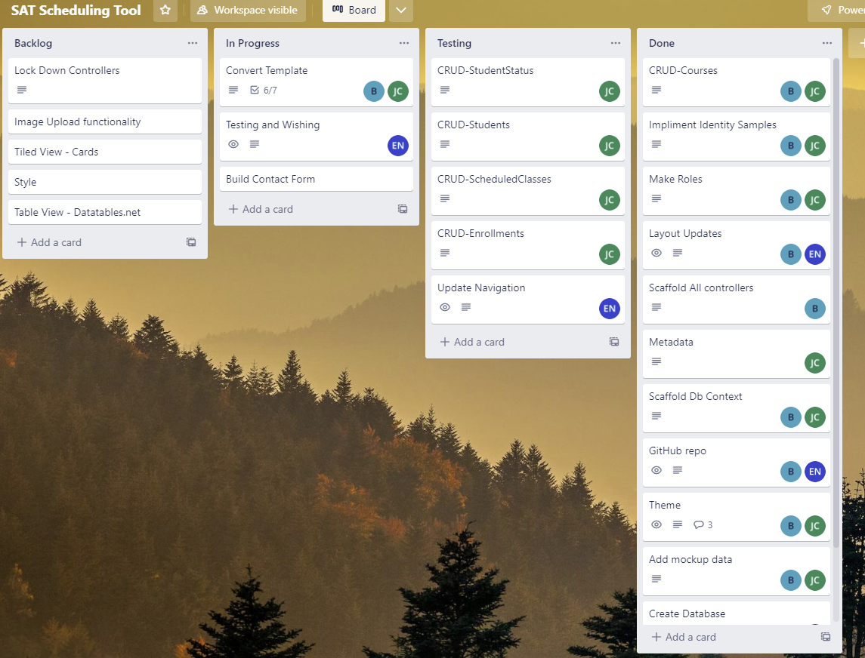

20Jan2023:

Contact form needs to be tested.

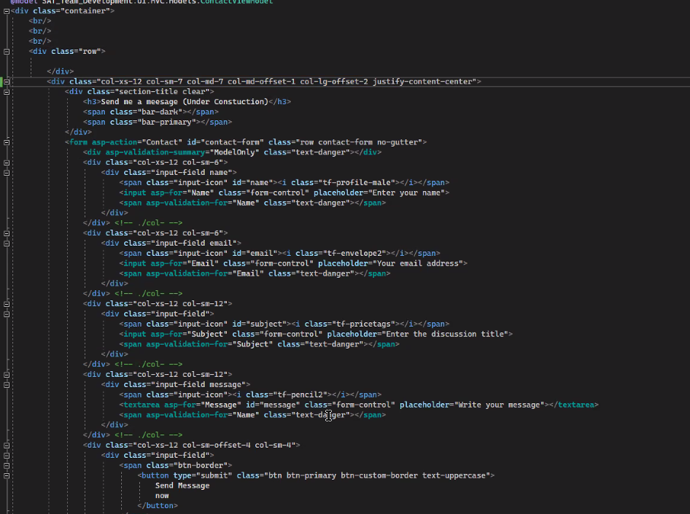

Created a separate email – decided to each use our own appsettings.json from previous projects for testing.

Installed the mailkit packages.

Used the email confirmation view layout from personal-storefront.

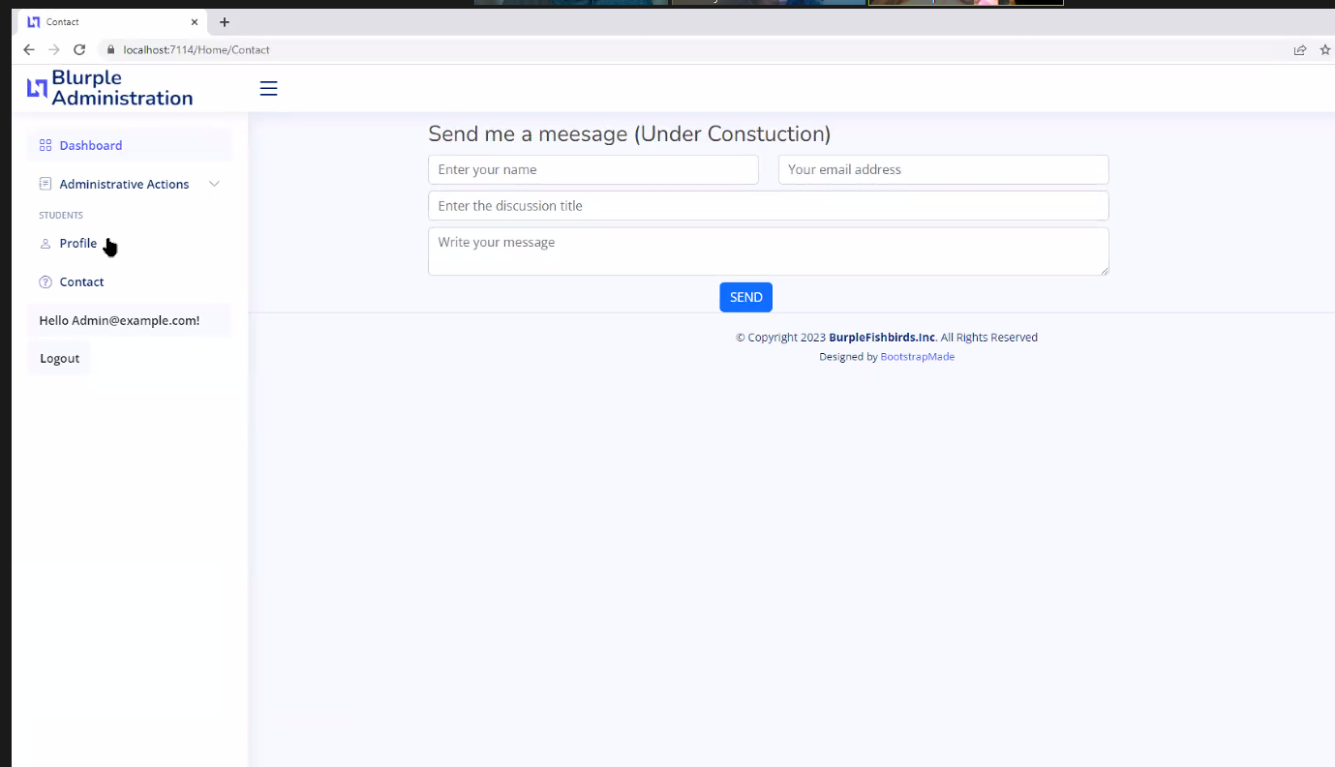

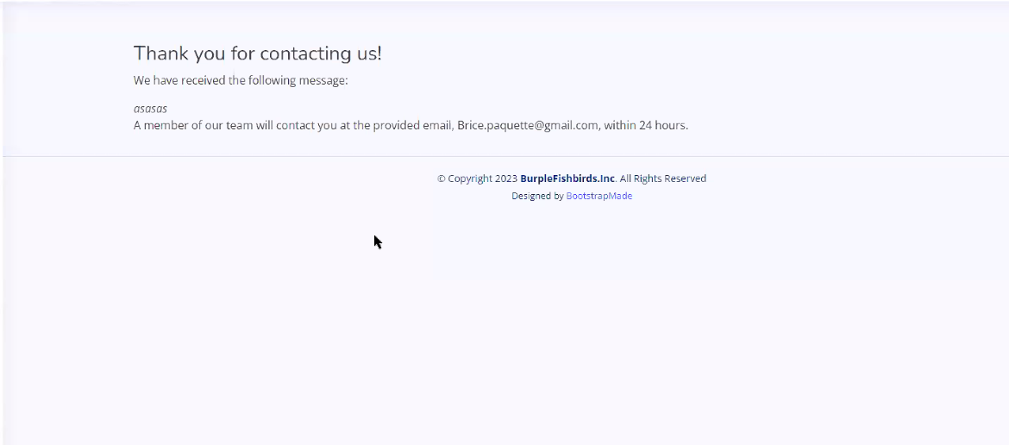

Created and tested contact form. Also added a message sent conformation.

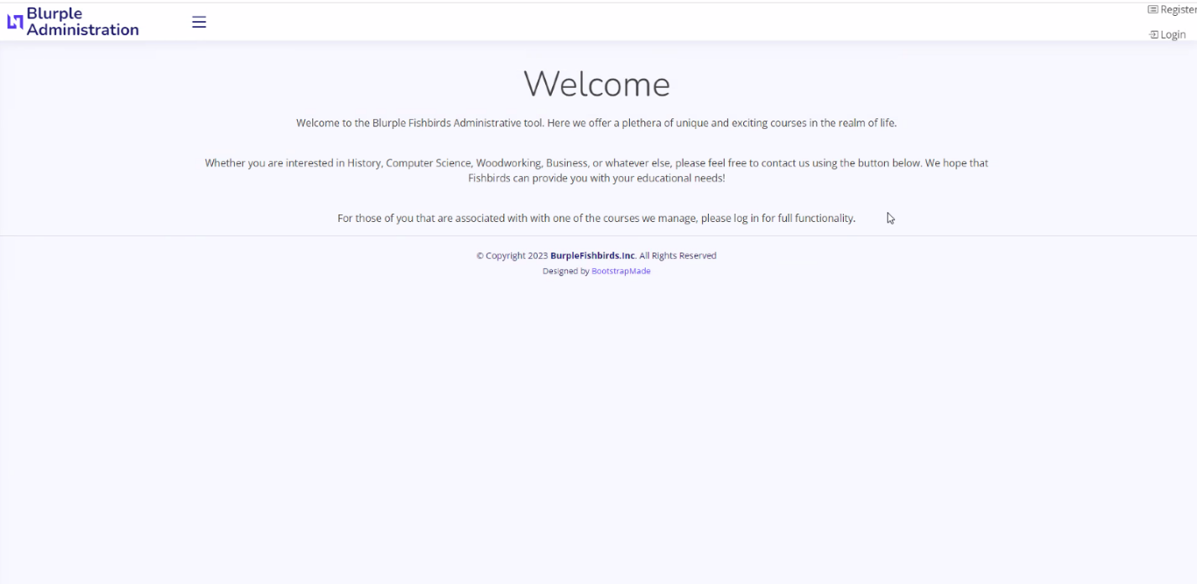

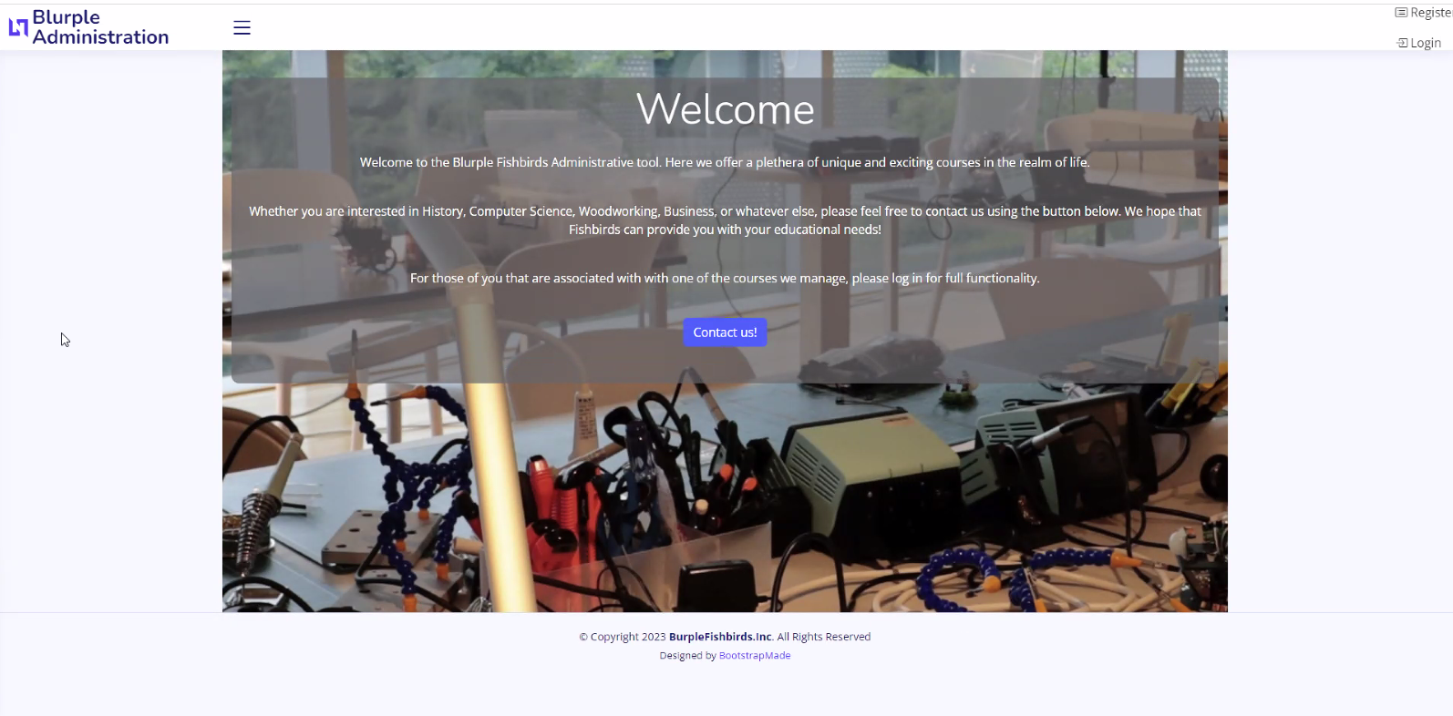

Created and styled the Home/Landing page for site with a button to take you to the contact form.

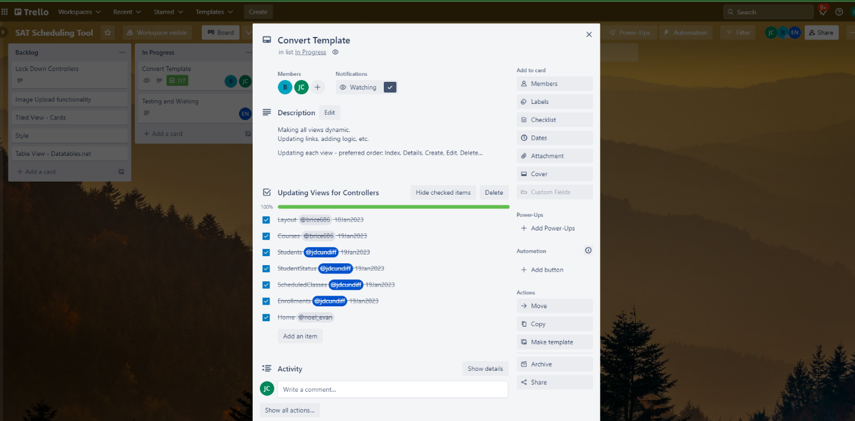

With the Home/Landing and contact form done the template conversion is complete.

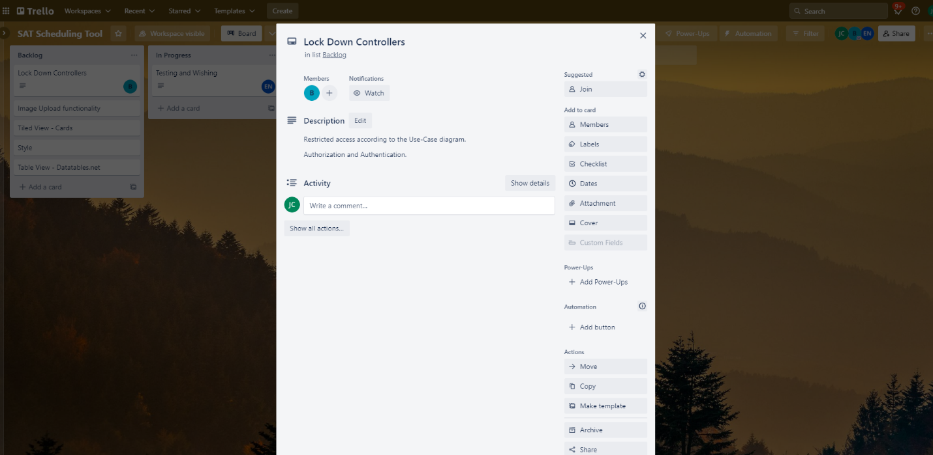

Locking down the controllers was completed

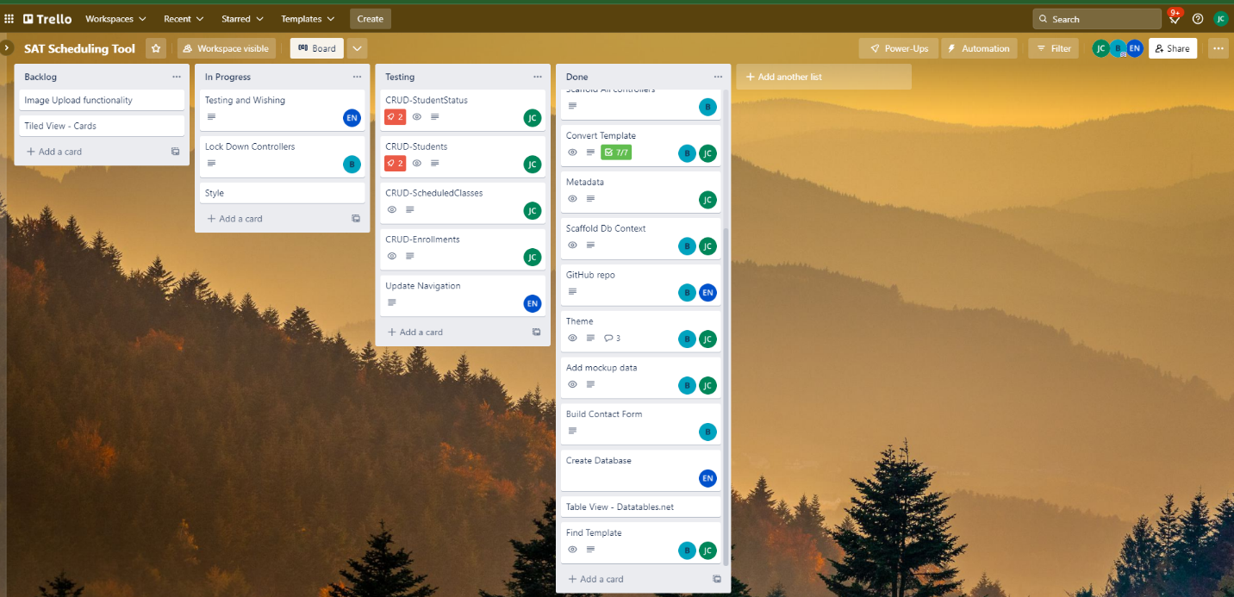

Trello board update.

